**Association** is a relationship between two separate classes which can be of any type say one to one, one to may etc. It joins two entirely separate entities.

**Aggregation** is a special form of association which is a unidirectional one way relationship between classes (or entities).

For e.g. Wallet and Money classes. Wallet has Money but money doesn’t need to have Wallet necessarily so its a one directional relationship. In this relationship both the entries can survive if other one ends. In our example if Wallet class is not present, it does not mean that the Money class cannot exist.

**Composition** is a restricted form of Aggregation in which two entities (or you can say classes) are highly dependent on each other.

For e.g. Human and Heart. A human needs heart to live and a heart needs a Human body to survive. In other words when the classes (entities) are dependent on each other and their life span are same (if one dies then another one too) then its a composition. Heart class has no sense if Human class is not present.

**Aggregation**

An Aggregation is an Association which denotes an "is part of" relationship.

Aggregation -> Weak Has-A relationship.

**Associations**

Objects are often associated with, or related to, other objects

The arrowheads on the end of the line indicate the directionality of the association.

A line with one arrowhead is uni-directional whereas a line with either zero or two arrowheads is bidirectional.

**Composition**

Sometimes an object is made up of other objects.

Notes:

Association means Has-A relationship.

Inheritance means Is-A relationship.

Both Composition and Aggregation are Associations.

Composition ->Strong Has-A relationship

Aggregation -> Weak Has-A relationship.

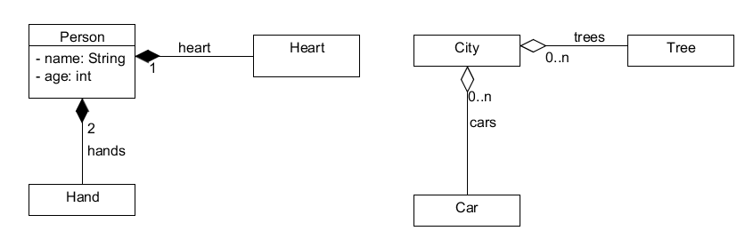

class Person {

private Heart heart;

private List<Hand> hands;

}

class City {

private List<Tree> trees;

private List<Car> cars

}

In **composition** (Person, Heart, Hand), "sub objects" (Heart, Hand) will be destroyed as soon as Person is destroyed.

In **aggregation** (City, Tree, Car) "sub objects" (Tree, Car) will NOT be destroyed when City is destroyed.

The bottom line is, composition stresses on mutual existence, and in aggregation, this property is NOT required.